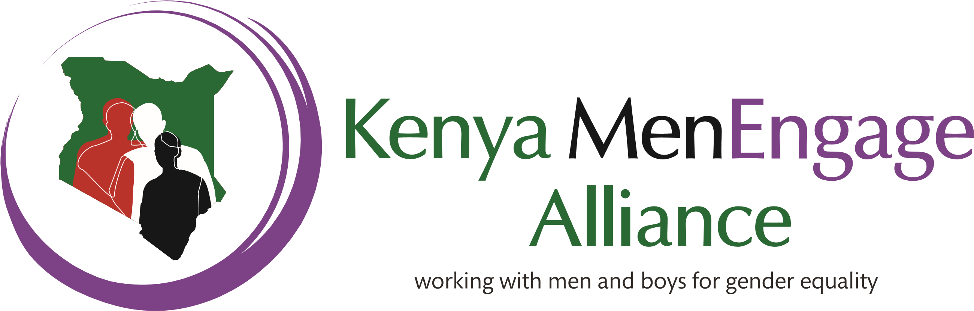
Vision: A Kenya society free of any forms of gender inequalities.
Mission: To increase the participation of men and boys in eliminating Gender Based Violence, promoting Sexual and Reproductive Health, positive fatherhood and the well-being of men, women and children in the society. KEMEA is also committed to building partnership with organizations, institutions and governments.

Kenya MenEngage Alliance works to end gender injustice in all its many manifestations and to promote gender equality and women empowerment. According to a growing body of evidence, well-implemented interventions targeting men and boys can positively impact on their attitudes and behaviours with regard to violence against women, and encourage them to challenge similar violent behavior among other men. This impact has, in turn, led to significant reductions in intimate partner violence and other practices that are detrimental to the wellbeing of women and children. Given the high levels of violence perpetrated against women across the country (KDHS 2014) particularly domestic violence, changes to men’s behavior will have a direct effect on the levels of violence experienced by women and girls. Men are also the gate-keepers within many institutions, including as policy-makers and as parliamentarians, yet so often remain disinterested or uninvolved in the spheres of gender equality and violence prevention. By engaging men and especially men in positions of authority, their potential is realized to eliminate harmful cultural practices, promote women’s rights and support the development of new GBV laws and policies, strengthen the implementation of existing policies, and create male role models that can challenge and support other men to change.
How KEMEA Works
- Network currently hosted by Movement of Men Against Aids In Kenya (MMAAK)
- 14 member organizations and individuals
- Operating through a Steering Committee chaired by National Coordinator.
- Governed by Terms of Reference for the Steering Committee.
- Steering Committee convenes quarterly
- Projects implemented through members with Project Officers coordination.

FGM work in Kenya and in the Region
Through the support of The Girl Generation (TGG), KEMEA Member, The Margaret Wanzuu Foundation was granted to sensitize religious and Traditional leaders on the effects of FGM as well as recruit and train Community Change Agents (CCA’s) in Kuria, Migori Country. The project was implemented in 8 months and produced enormous results because it led to another grant to implement End Child marriages activities through conducting Dads and Daughters workshops. It also led to the religious and traditional leaders giving the Community change agents platforms in churches to speak against FGM.
In order to Address Cross-Border FGM,KEMEA through Margaret Wanzuu Partnered with Children Dignity Forum based in Tarime-Tanzania to conduct advocacy on FGM across the border of Sirare.
As a member of MenEngage Africa, KEMEA through the national Coordinator, attended the Pan African Parliament in Johannesburg and has access to platforms as the East African Community (EAC) and African Union (AU).
KEMEA key partners include the Kenya Anti-FGM Board, FEMNET and Equality Now.

